**End of Term Newsletter**

Wow! What a busy term it has been. 5/6D settled really well into their new class and immediately began to show what great school leaders they will all be this year. In Week One we had a Leadership Day where they learned how to work as a team, how to set goals and work towards them and how to show perseverance and resilience as school leaders. Their determination to achieve their goals has been amazing and we are very proud of them.

**Leadership Day**

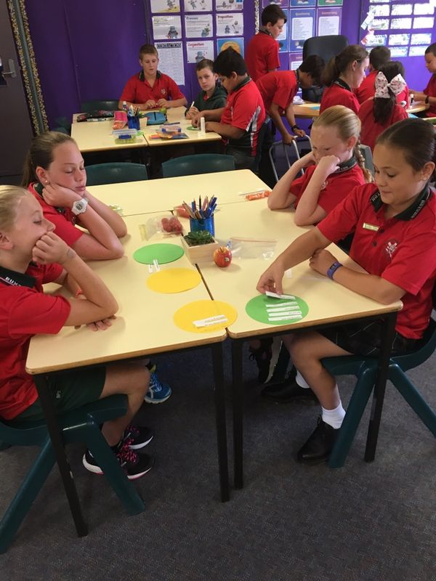

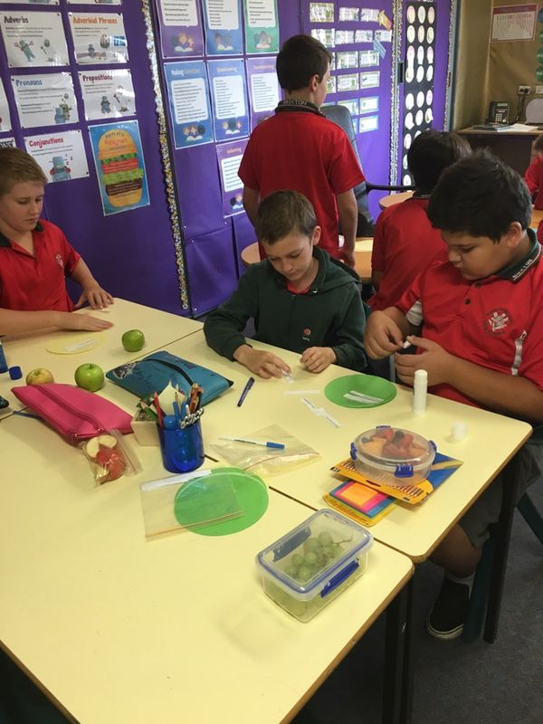 Week One Leadership Day- What are the characteristics of a school leader? Als school leader? We We also learned how to work as a team.

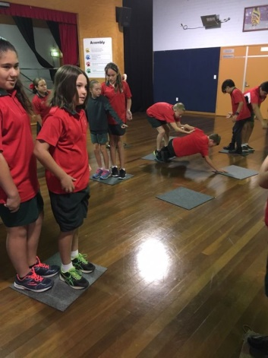

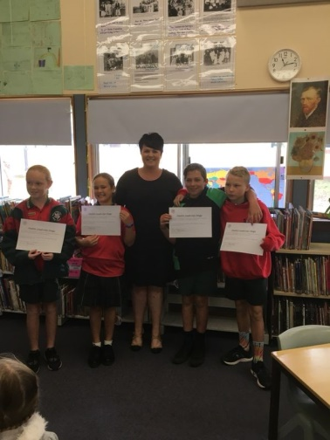

Our School Captains were sworn in as leaders at a special morning tea with Mrs Rourke and the Assistant Principals.

Year 6 also showed their leadership skills in leading our students K-6 in our PBL (Positive Behaviour for Learning ) Matrix Day. They explained to every student the goals for all areas of our school environment, and what a magnificent job they did.

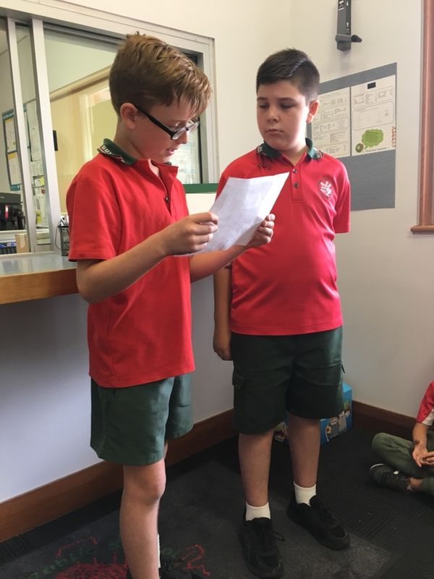 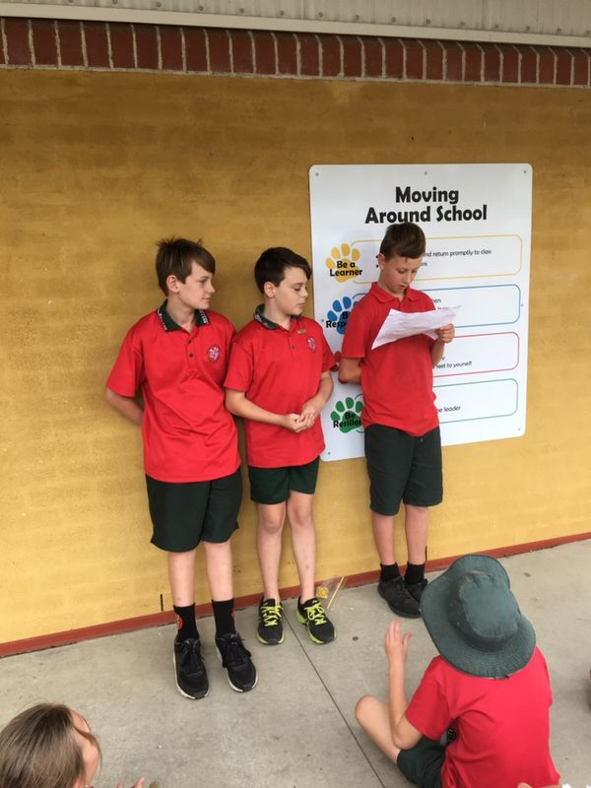 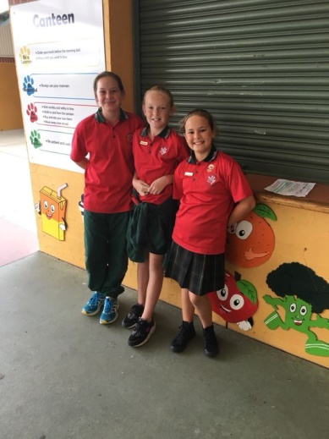

**English**

Every student in 5/6D has set their own personal learning goal in writing. They have also looked at their cluster achievement on the Literacy Continuum and set their own goal to work towards the next cluster for the next few weeks. As soon as the goal is achieved a new goal is chosen.

There has been some very outstanding writing this term. We have read so many quality book, here are a few examples of students’ writing.

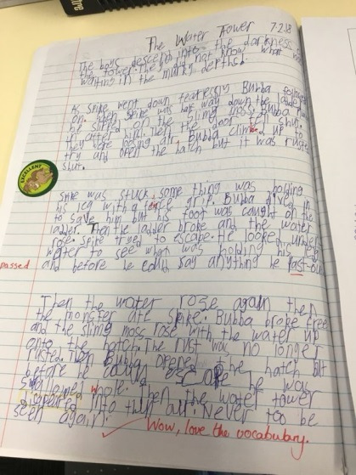 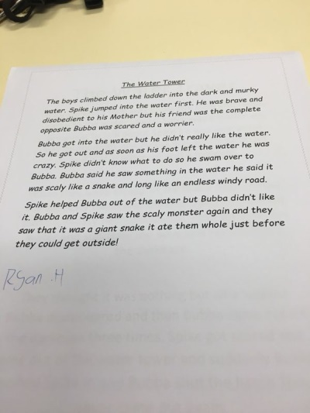 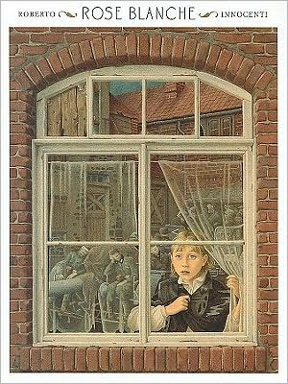

The story of Rose Blanch was gripping and very moving. Students made connections with their learning last year about the Second World War and wrote some very immotive pieces of work.

Students read every day in school and some are consistently engaging in reading at home. We encourage our students to read (anything!). Reading helps to improve spelling and teaches us so much about the world around us. Every job that anyone does will require some reading.

**Mathematics**

This term students have studied: Whole Number including: Decimal place value;Addition and Subtraction; Multiplication and Division; Fractions and Decimals; Length; Three Dimensional Space; Angles and Time. Everyone is learning mastery of multiplication tables. Students are learning that math is fun! They are learning to problem solve and apply their learning to the real world.There is so much to learn and they are engaging every day in hands on activities as well as using more formal strategies.

Measuring perimeter

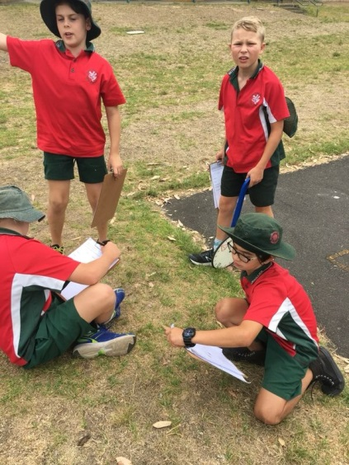 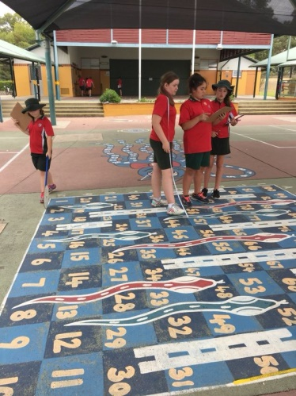

**History**

We have studied the unit ‘The Australian Colonies’. Students have learned about the harshness of life for the early colonists. They have studied famous Australians and also looked at the impact of colonisation on the Aboriginal people.

**Science**

Students thoroughly enjoyed designing and making a slab hut. They enjoyed the practical part as these photos will show you.

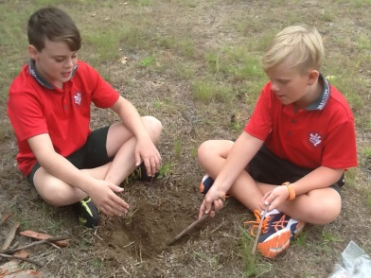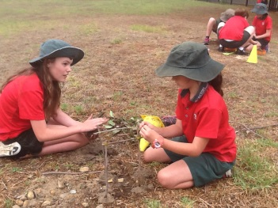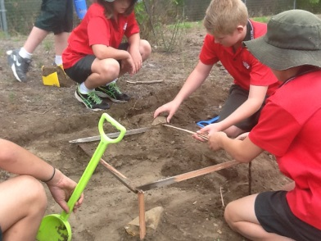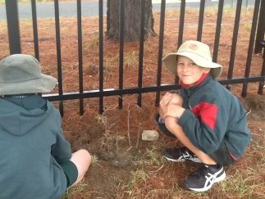

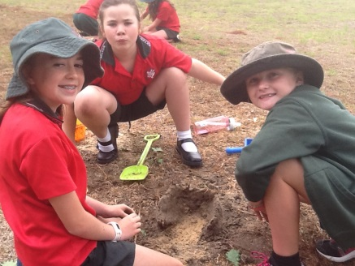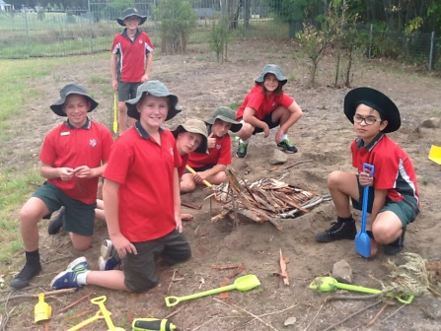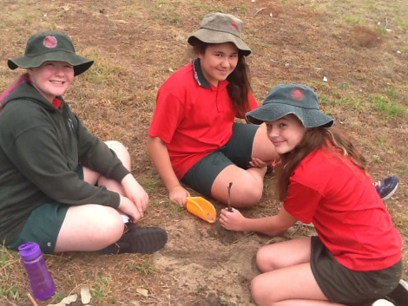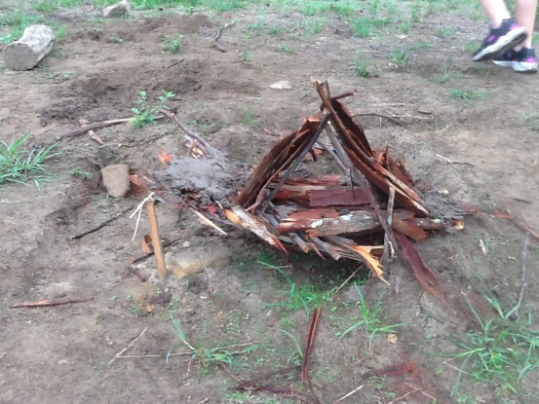

**Visual Arts**

Kadinsky, Jason Pollock and Andy Warhol are a few famous artists that have inspired students to create their own masterpieces.

**PDHPE**

Congratulations to our students for their superb effort with the swimming carnival at the beginning of this term. For some it wasn’t about winning but taking part and earning points for their house. Well done to each and everyone of you!

We would like to wish you and your family an enjoyable school holidays and look forward to next term.

Kind regards

Mrs Davies Mrs Lamplough

**Fundraising for the Farewell**

Thank you for your support with our fundraising for the Farewell, everyone played a part in this and it was lovely to see our students so willing to help on the day.

