**Term 1 Blurb- 4/5I**

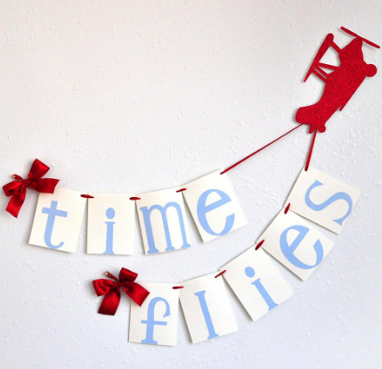Wow! Time sure does fly when you are having fun. As we approach the completion of Term 1, I can honestly say it has been a fabulous experience getting to know each and every lovely learner in my class. Routines have been established, high expectations set and personal bests are being achieved.

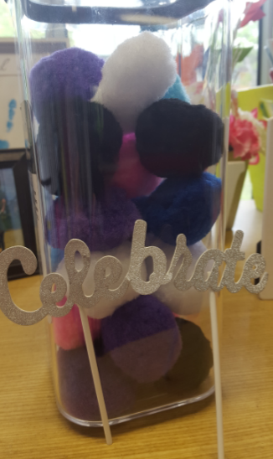

4/5I are a bubbly, fun, inquisitive group who demonstrate the upmost care towards the younger members of BPS. How delightful! I am proud of how our team work skills are developing week by week and am pleased to say that we celebrated our first milestone of earning *24 pom poms in our jar*. The students built reading forts and had glow sticks to illuminate their creations! Favourite books and games were read and played and a good time was had by all. I am looking forward to our next teamwork celebration- “Jelly in your Belly Day.”

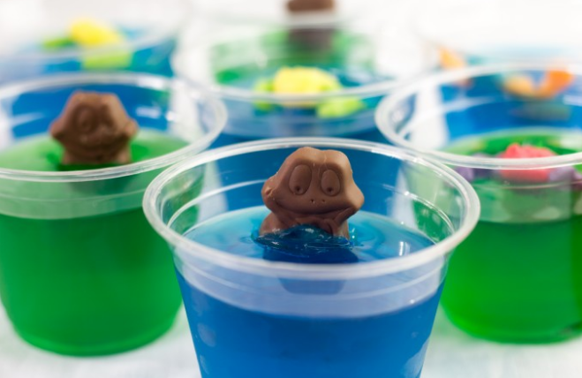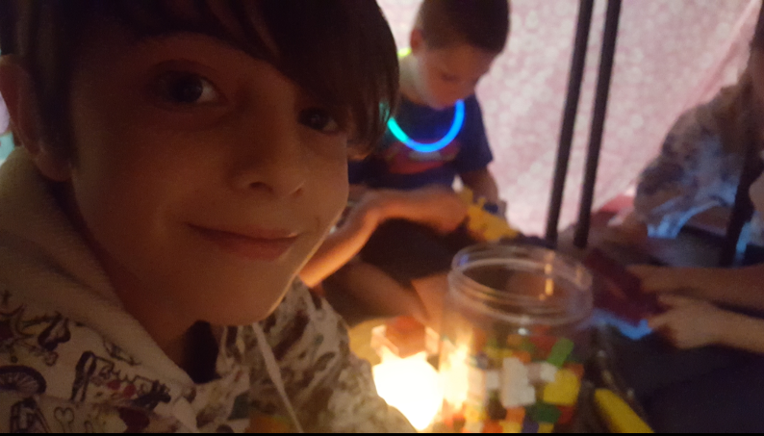

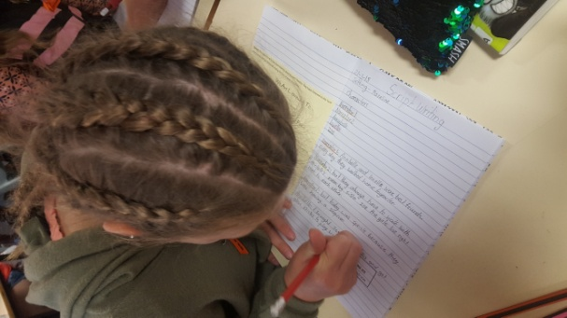The students are becoming more and more confident with creating and using our Learning Intentions and Success Criteria wall to guide their learning. I am so excited to see that the students are confidently telling both myself and visiting teachers such as Mrs Rourke and Mrs Davies about their learning strategies and learning goals. The students have commenced using various checklists to monitor their own learning to achieve the best possible learning outcomes.

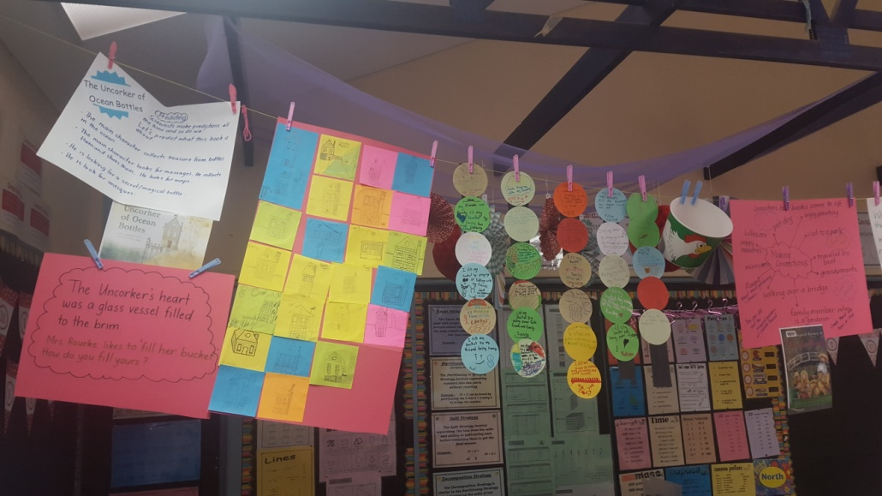

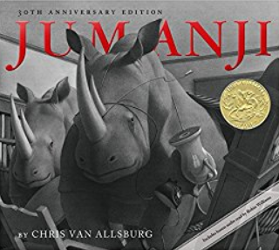 Students in 4/5I are so enthused to listen to stories. It is a privilege to share various quality texts with them. Their insights and ideas about the content is rich and informative. We have been writing to inform, persuade and entertain. Our most popular task has been writing letters to our new friends at our buddy school. We can’t wait to actually receive the letters back and find our more about the kids!

Well done, to all the children participating in the BPS Home Reading Program. Our library is an amazing place for the students to borrow lovely texts which interest them. Magazines and online texts are also a great way for the students to accumulate their reading minutes.



I love during Maths lessons when the children say, “Now, I get it!” We complete a mixture of hands on and written tasks to expand our knowledge of Mathematical concepts. Students are encouraged to records their ideas, working out, and answers in a way which supports their ability to speak about their understandings. We are currently studying Fractions and Decimals and I have seen many light bulb moments.

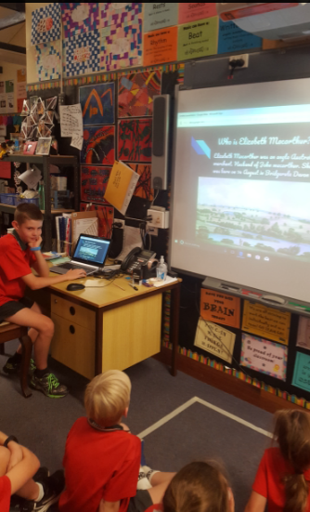

In History, many of the students have created informative projects about famous Indigenous Australians and colonists. It has been marvellous to see the students proudly present their creations and for the students to learn from one another. I also have learnt from the students.

Science lessons have revolved around building a shelter from natural materials. The students have creatively and diligently applied themselves to this tricky mission with gusto. The shelters are a work in progress. We have watched some amazing You Tube clips about how to design and build a structure for protection from the elements. We may have some future architects, builders and interior designers in the making!

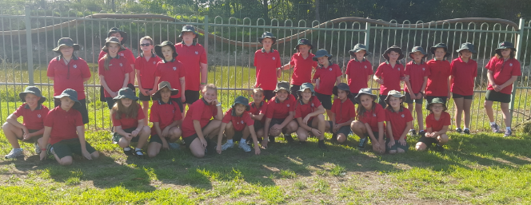

4/5I have participated in many art experiences this term linked to our History unit. We currently have a display of art work in the hall which we invite you to see. Art and creative expression forms an integral part of learning. It is fantastic to see the students enjoying the process of drawing, designing and making pieces of art such as paintings, weaved items and collages.

The Rugby League clinics have been a highlight of the term with lots of fabulous and motivating games being taught to the students. The students actively participated in the games and showed a keen interest in refining their throwing and kicking skills.

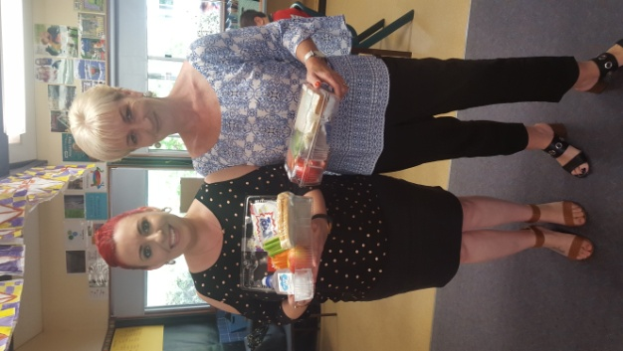**Free Lunch**

**from IGA**

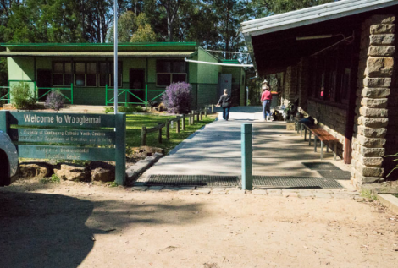Thanks to Rani and all the parents and friends for voting for us!

Year 4 Camp was amazing!

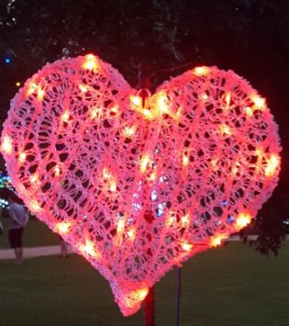I would like to express my thanks to the students of 4/5I for your huge efforts this term. Thanks also to the fabulous parents who I am getting to know more and more each week both in person and via See Saw. All the best for a happy and safe Autumn holiday. I can’t wait for another term filled with spectacular and challenging

learning experiences.